Zheng, Zhi

Project

Time Series Analysis For Business

2) Do file and log file for step 1 of model selection. For total private employment and average weekly earnings for all private employees, use VSELECT to estimate and evaluate some alternative models you think are reasonable. Take the log and difference if doing so is called for, don’t if it is not called for. For a reasonable set of models from VSELECT, also calculate the LOOCV. Include a simple 12-lag AR only model as a benchmark. Prepare a table summarizing the fit measures for these reasonable models.

1. Vselect models for forecasting All Employees: Total Private in Miami-Fort Lauderdale-West Palm Beach, FL (MSA)

After testing many different models with different predicators, the best variables to use with forecasting All Employees in Miami-Fort Lauderdale-West Palm Beach, FL (MSA) are first differenced & logged All Employees, Labor Force and Unemployment ratio in Miami-Fort Lauderdale-West Palm Beach, FL (MSA). After running the vselect to estimate and evaluate the models with 12-Lags for each predictor variables, the results are:



Then, I selected models from #Preds 4-10 as the best models, because model 4 have the best BIC score and model 10 have the best AIC score. Finally, I ran regression on these models plus a simple 12-lag AR model to get LOOCV RMSE and other calculations to get a table summarization. The result is shown below:



The 12-lag AR simple model have the lowest LOOCV RMSE result, the model 5 have best BIC result, and model 8 have best AIC result. In conclusion, Model 5 are the best fit model other than the 12-lag AR model.

1. Vselect models for forecasting Average Weekly Earnings of All Employees: Total Private in Miami-Fort Lauderdale-West Palm Beach, FL (MSA)

After testing many different models with different predicators, the best variables to use with forecasting Average Weekly Earnings in Miami-Fort Lauderdale-West Palm Beach, FL (MSA) are first differenced & logged Average Weekly Earnings, Average Hourly Earnings and Average Weekly Hours in Miami-Fort Lauderdale-West Palm Beach, FL (MSA). After running the vselect to estimate and evaluate the models with 12-Lags for each predictor variables, the results are:

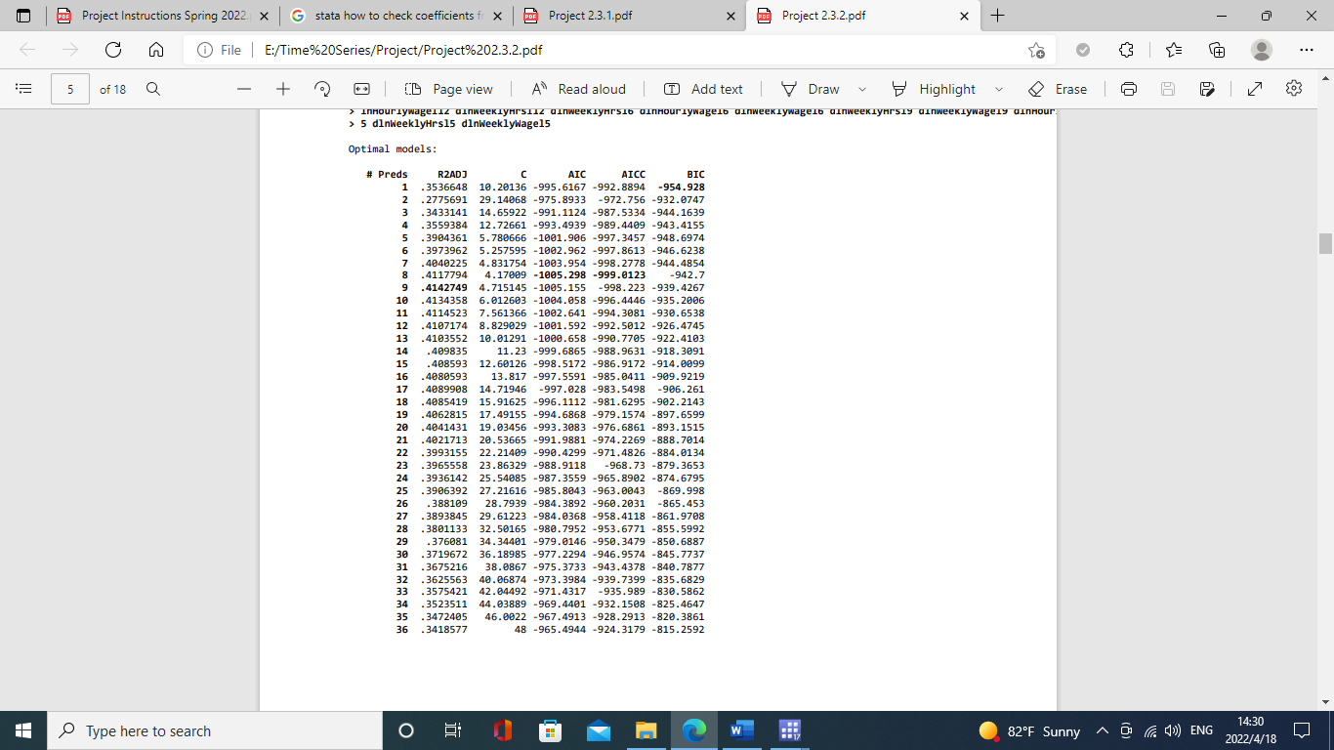

Then, I selected models from #Preds 1-8 as the best models, because model 1 have the best BIC score and model 8 have the best AIC score. Finally, I ran regression on these models plus a simple 12-lag AR model to get LOOCV RMSE and other calculations to get a table summarization. The result is shown below:



The Model 8 have the lowest LOOCV RMSE result and AIC result, the Model 5 have BIC result. In conclusion, Model 5 are the best fit model because it has the best information criterion scores (BIC) and the simplest model.